Code 1.1.4 } Write a Python program that prompts the user to enter the triangle's base and height and computes the triangle's area.

Algorithm :
Step 1 : start
Step 2 : input of base and height
Step 3 : calculating area = 0.5 * base * height
Step 4 : stop

Code :
base = float(input())
height = float(input())
area = 0.5 * base * height
print(f”{area:.2f}”)

Flowchart :
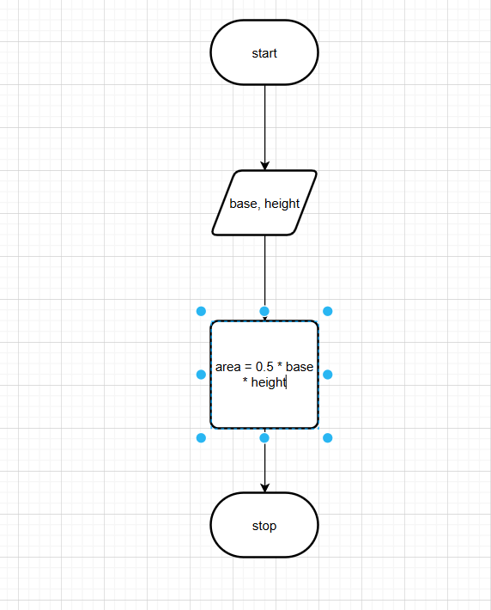

Codetantra :
